Source https://www.viator.com/tours/Honolulu/Oahu-Circle-Island-Snorkeling-Tour-16-Points-of-Interest/d59070-191335P1
__________________________________________________________

Oahu Circle Island Explorer: North Shore Snorkeling & Coastal Highlights
__________________________________________________________
★★★★★ 4.5/5 20 reviews

Add to wishlist ♡

__________________________________________________________

10 Hours | €120 per person

🏕  Image | 🏕  Image | 🏕  Image | 🏕  Image | 🏕  Image | 🏕  Image

__________________________________________________________
Experience Overview
See Oahu in one action-packed day with a full circle-island journey designed to cover the island’s most scenic viewpoints, cultural landmarks, and legendary coastal stops — crowned with a North Shore snorkeling session. Along the way, you’ll travel from dramatic lookouts and hidden coves to local farms, famous beaches, and iconic attractions such as the Dole Plantation. With convenient pickup options, expert guidance, and snorkeling gear included, this experience is built for travelers who want to maximize their time while seeing Oahu’s greatest hits in one seamless adventure.
__________________________________________________________
Tour Snapshot
- Duration: Approx. 10 hours
- Meeting Point: Ala Moana Harbor pickup is at the Ilikai Hotel (flagpole in front, next to the harbor) — pickup must be confirmed with the tour operator after booking
- Group Size: Maximum 40 travelers
- Accommodation: Not included (day tour experience)
- Languages Available: English
- Private Tour: Not included (shared guided tour)
- Transportation: Included via tour vehicle (pickup offered at selected Waikiki locations)
- Accessibility: Not wheelchair accessible (stroller accessible; service animals allowed)
- Season: Available year-round
__________________________________________________________

Check Dates & Availability

Select participants: (Age 99 and younger) - 1 +

Choose date:
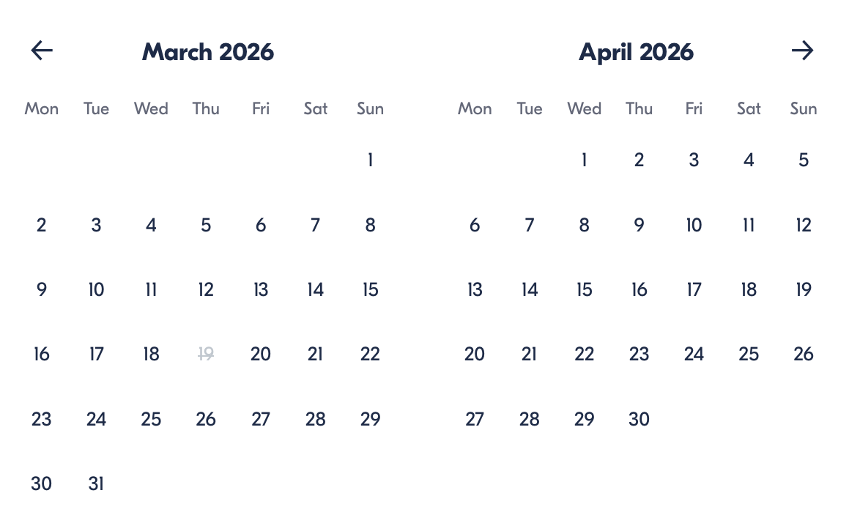

Check Availability

opens:

Participants: 1 March 16, 2026

Oahu Circle Island Explorer: North Shore Snorkeling & Coastal Highlights

- Duration: 10 hours
- Offered in: English
- Starts at: 7:00 AM

Cancellation:

- More than 24 hours before start: Full refund
- Less than 24 hours before start: No refund

Price breakdown: 1 Participant x €120

Total: €120

The total price includes all taxes and fees.

Add to cart Book now

__________________________________________________________
Tour Highlights
- Diamond Head Sunrise Viewpoint: Start the day with panoramic ocean scenery from Amelia Earhart Lookout.
- Coastal Wonders: See Halona Blowhole and scenic drives along Makapuʻu Point with its famous lighthouse views.
- Cultural Stop: Visit the tranquil Byodo-In Temple in the Valley of the Temples.
- North Shore Lifestyle: Explore Haleiwa and experience the island’s surf culture and laid-back charm.
- Snorkeling with Turtles: Enter the water at Haleiwa Alii Beach Park and snorkel where sea turtles are often spotted.
- Local Farms & Flavors: Stop at Tropical Farms (macadamia nuts + Kona coffee), Kahuku Farms, and Green World Coffee Farm.
- Dole Plantation: Discover Hawaii’s pineapple legacy and enjoy classic treats like DoleWhip (available for purchase).
__________________________________________________________
Detailed Itinerary

Day 1 – Oahu Circle Island Tour & North Shore Snorkeling
Your island day begins early with pickup, then heads straight to the breathtaking Diamond Head Lookout (Amelia Earhart Lookout) for a scenic sunrise-style view over the Pacific. Cruise by the upscale Kahala coastline, then pause at Eternity Beach — a quiet cove known for its cinematic fame and peaceful ocean backdrop.
Continue along Oahu’s southeastern shoreline to the Halona Blowhole, where waves surge through lava rock formations and burst upward in dramatic sprays. The route follows a scenic drive past Makapuʻu Point, offering sweeping views of rugged cliffs, bright turquoise waters, and the historic Makapuʻu Lighthouse.
Next, step into calm at the Byodo-In Temple, a replica of an ancient Japanese temple set within the Valley of the Temples. Afterward, visit Sandy Beach Park, famous for powerful waves and a wild coastal atmosphere. You’ll also stop to admire Mokoliʻi Island (Chinaman’s Hat), one of the island’s most photographed offshore landmarks.
As the tour reaches the North Shore, enjoy the relaxed energy of Haleiwa — browse shops, sample local treats, and take in the aloha spirit. Along the way, explore Tropical Farms for macadamia nuts and Kona coffee, then stop at Kahuku Farms to see and taste local tropical produce.
A major highlight is time at Haleiwa Alii Beach Park, where you’ll snorkel in clear water and may encounter sea turtles in their natural habitat. Later, visit the Dole Plantation to explore the island’s agricultural heritage and browse souvenirs, before wrapping up at Green World Coffee Farms to see coffee trees and sample boutique Hawaiian coffee (available for purchase). After a full day of discoveries, you’ll return to Waikiki.
Accommodation:
Not included (day tour experience)
__________________________________________________________
Included in Price
- Bottled water
- Snorkeling equipment
- Snacks
__________________________________________________________
Not Included
- Lunch
- Towels
- Sunscreen
__________________________________________________________

Not Suitable For
- Wheelchair users
__________________________________________________________
Important Trip Information
- Pickup Details: Pickup is offered, including the Ala Moana Harbor area at the Ilikai Hotel flagpole (next to the harbor). Pickup is not automatically assigned — guests must contact the tour company after booking to confirm the pickup location.
- Family Notes: Infants must sit on laps.
- Accessibility: Stroller accessible; service animals permitted; near public transportation.
- Capacity: Maximum 40 travelers.
- Participation: Most travelers can take part; confirmation is provided at booking.
- Weather Flexibility: Certain stops may be affected by weather or other conditions and could be modified.
__________________________________________________________

Cancellation Policy
Cancel at least 24 hours before the start time to receive a full refund.
- Cancellations within 24 hours are non-refundable.
- Changes within 24 hours are not accepted.
If the tour is canceled due to poor weather or minimum traveler requirements not being met, you’ll be offered a different date/experience or a full refund.
__________________________________________________________
What Our Clients Are Saying

Overall rating  4.5/5  ★★★★★  Based on 20 reviews | Review summary  Guide 4.5/5  Transportation 4.6/5  Service 4.7/5  Organisation 4.5/5

Filter  - All traveller types  - Couples  - Group of friends  - Families  By star rating  - All star ratings  - 5 stars  - 4 stars  - 3 stars  - 2 stars  - 1 star | Search reviews (e.g., guide)  Sort by:  - Top picks  - Latest reviews  - Best ratings  - Lowest ratings
__________________________________________________________
★★★★★
Megan T. — United States
A brilliant way to see Oahu in one day. The scenery was unreal, and snorkeling on the North Shore was the absolute highlight.
★★★★☆
Luis A. — Mexico
Great tour with a strong itinerary. It felt a bit fast at times, but we covered so many places, and the snorkeling was fantastic.
★★★★★
Nina K. — Germany
An amazing day from start to finish. Beaches, viewpoints, temples, farms — and snorkeling with turtles was unforgettable.
See more reviews
__________________________________________________________

Meta tags

Page - Oahu Circle Island Explorer: North Shore Snorkeling & Coastal Highlights

Title: Oahu Circle Island Explorer: North Shore Snorkeling & Coastal Highlights | Travellio Global

Description: Explore Oahu’s iconic sights on a full-day circle island tour featuring Diamond Head views, cultural stops, local farms, Dole Plantation, and North Shore snorkeling with sea turtles.

H1 - Oahu Circle Island Explorer: North Shore Snorkeling & Coastal Highlights
__________________________________________________________

